Mira Nur Aulia  
222310018  
TI22PA1  
Quiz Lab Pweb

1. Halaman Dashboard

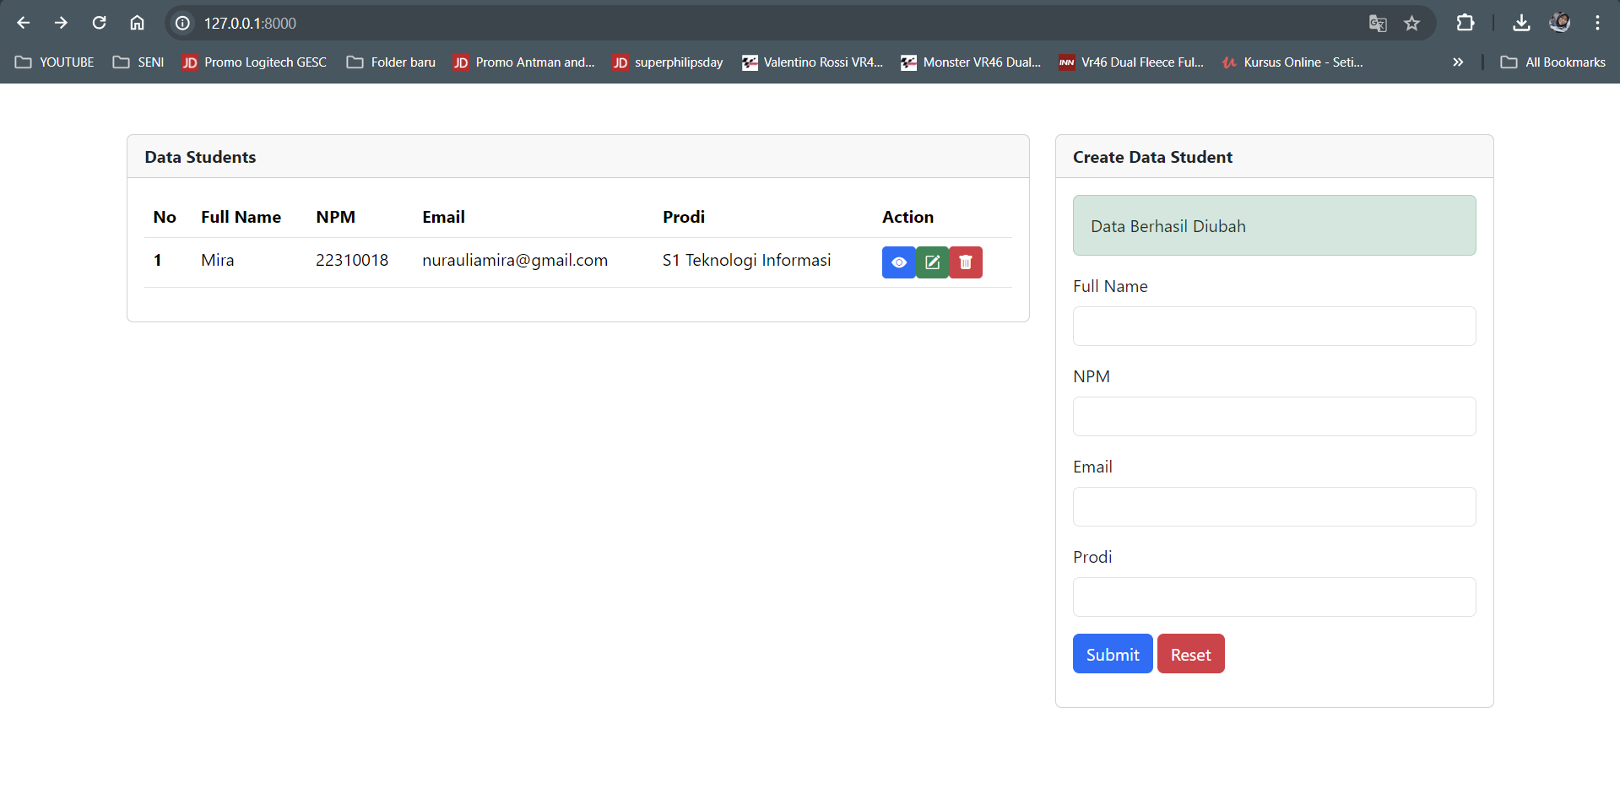

1. Halaman detail

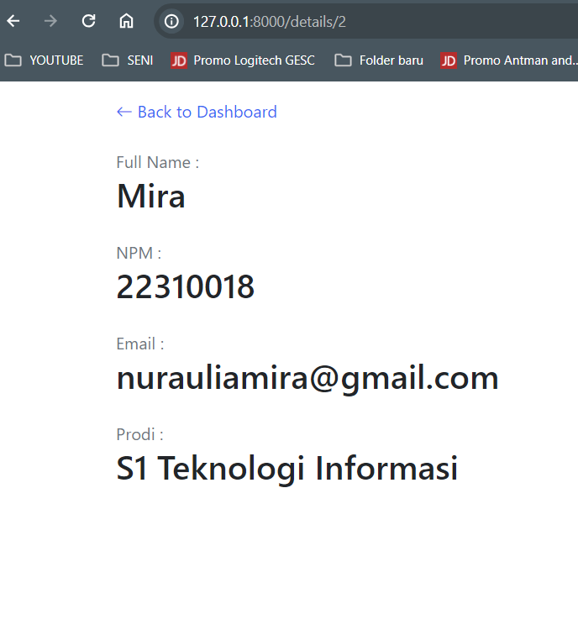

1. Halaman Edit

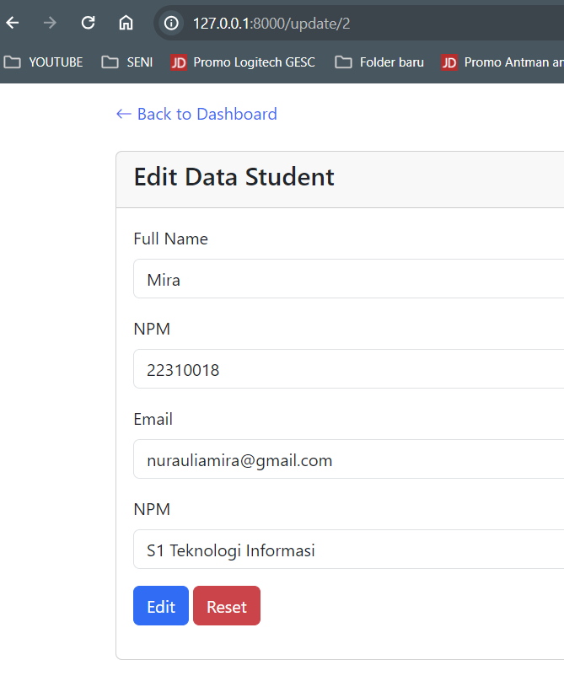

1. Hapus data

